Node.js CI/CD Pipeline with Jenkins, NodeJsScan, and Semgrep
This project implements a secure CI/CD pipeline using Jenkins to automatically build, test, and scan a Node.js application with NodeJsScan and Semgrep, then upload the results to Amazon S3 for storage and analysis.
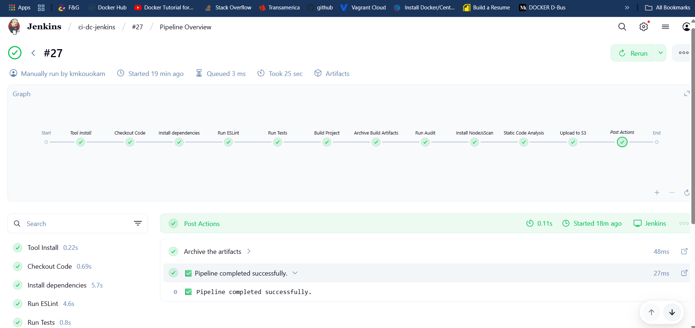

🚀 Prerequisites

Ensure the following tools and configurations are in place before running the pipeline.

✅ Jenkins Setup
- Jenkins installed on an Ubuntu/Debian server.
- Docker installed and running.
- Add the `jenkins` user to the Docker group:
sudo usermod -aG docker jenkins
- Restart Jenkins or log out and log back in to apply group changes.

✅ Required Jenkins Plugins
Make sure these plugins are installed via Manage Jenkins > Plugins:
- Pipeline Utility Steps
- Pipeline: AWS Steps
- Amazon Web Services SDK
- NodeJS Plugin
- Git Plugin

🔐 AWS Credentials
1. Create an IAM user in AWS with permission to upload to your S3 bucket.
2. Add AWS credentials in Jenkins via: Manage Jenkins → Credentials → Global → Add Credentials

🧠 Semgrep Setup on Jenkins Node (Required)
Install Semgrep directly on the Jenkins agent or controller that will run the scan.

1. Install Python 3.9+ and Required Tools
sudo apt update && sudo apt install python3-full python3-venv python3-pip -y

2. Create and Activate a Virtual Environment
python3 -m venv ~/semgrep-venv
source ~/semgrep-venv/bin/activate

3. Install Semgrep
pip install --upgrade pip
pip install semgrep

🧪 Environment Variables in Jenkins Pipeline
Configure the following variables in your Jenkinsfile under the environment block:

environment {
AWS_REGION = 'us-east-1'
AWS_CREDENTIALS_ID = 'your-jenkins-credentials-id'
S3_BUCKET = 'your-s3-bucket-name'
DIST_DIR = 'dist' // Build output directory
REPORT_DIR = 'reports' // Directory to store reports
}

🛠 Pipeline Stages Overview
1. Checkout Code
Clones the project from GitHub:
https://github.com/kmkouokam/prototype-ai-ds-frontend.git

2. Install Dependencies
Runs npm ci to install dependencies from package-lock.json.

3. Run ESLint
Lints JavaScript and TypeScript files using ESLint.

4. Run Tests
Executes automated tests. Pipeline will continue even if tests fail.

5. Build Project
Runs the app build. If the build fails, a fallback HTML file is generated.

6. Static Code Analysis (NodeJsScan + Semgrep)
Runs vulnerability analysis using:
- NodeJsScan (optionally Dockerized)
- Semgrep (from local virtual environment)

7. Generate Reports
Stores results in the reports/ directory.

8. Upload to S3
Uploads build artifacts and reports to Amazon S3 using AWS credentials.

9. Archive Artifacts
Stores reports and build files in Jenkins for future review.

📁 Output
- Build files: dist/
- ESLint output (console)
- Vulnerability reports:
- reports/nodejsscan-report.html
- reports/semgrep.json (if configured)
- All reports are uploaded to S3 under:
s3://your-s3-bucket/reports/<BUILD_NUMBER>/

📚 References
- NodeJsScan GitHub: https://github.com/ajinabraham/nodejsscan
- Semgrep Documentation: https://semgrep.dev/docs/
- Jenkins Pipeline Documentation: https://www.jenkins.io/doc/book/pipeline/

